Internationalization:

Number format - <https://www.youtube.com/shorts/H-FeuIKvHS4>

Relative time format - <https://www.youtube.com/shorts/Nn-5dTtVqqk>

<https://blog.webdevsimplified.com/2020-07/relative-time-format/>

<https://stackoverflow.com/questions/6108819/javascript-timestamp-to-relative-time>

<https://www.youtube.com/watch?v=acemrBKuDqw>

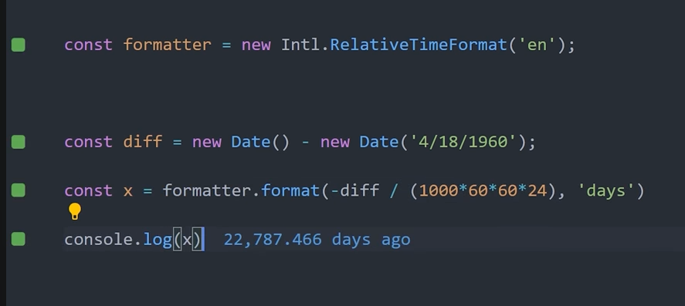

Social medio number format

<https://www.youtube.com/watch?v=FUngCjDzFDo>

Basic overview:

<https://www.youtube.com/watch?v=pDcskPY1yIs>

Remove comma before junction word..

